# Cybersecurity Interface Agreement

# Revision

Version 5

4/22/24 12:16 PM

# Author

Charles Wilson

# Abstract

This document details the process to be used to establish the cybersecurity interface agreement between a supplier and the customer organizations.

# Group / Owner

Security / Systems Security Analyst

# Motivation

This document is motivated by the need to have formal agreements in place for the development of security-related elements by a supplier to be used in products subject to compliance with standards such as **ISO/SAE 21434** and **ISO 26262**.

# License

This work was created by **Motional** and is licensed under the **Creative Commons Attribution-Share Alike (CC-SA-4.0)** License.

[**https://creativecommons.org/licenses/by/4.0/legalcode**](https://creativecommons.org/licenses/by/4.0/legalcode)

# Overview

The **Cybersecurity Interface Agreement** is intended to establish the following:

* identity of responsible individuals
* understanding of supplier capabilities
* responsibility of both consumer and supplier for the various AVCDL work products
* agreement upon the confidentiality level for the various AVCDL work products
* relevant comments of both consumer and supplier

**Note:** As the **AVCDL** **Cybersecurity Interface Agreement** is a legal agreement, it is a tracked document.

The following diagram illustrates the process to be used:

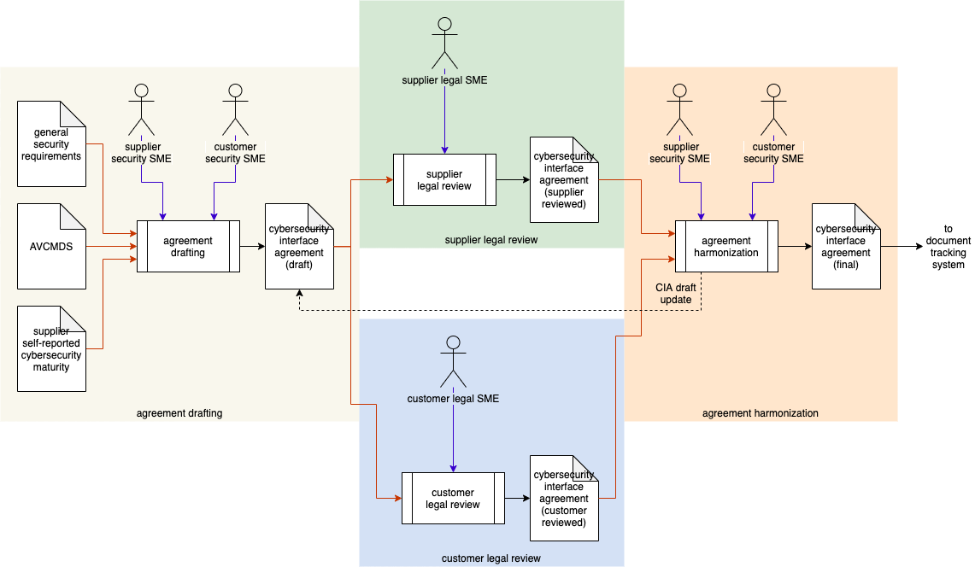

# Process

## Agreement Drafting

|  |  |
| --- | --- |
| **Inputs** | General security requirements  AVCMDS  Supplier self-reported cybersecurity maturity |
| **Outputs** | Cybersecurity Interface Agreement (draft) |
| **Participants** | Supplier Security SME  Customer Security SME |

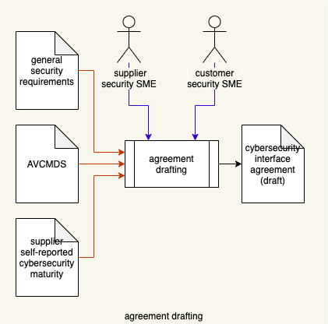

The **general security requirements** (*see note below*)for the element being supplied by the vendor, **AVCMDS (Autonomous Vehicle Cybersecurity Manufacturer Disclosure Statement)** worksheet **[12]**, and **supplier self-reported cybersecurity maturity** report **[13]** are used by the supplier and customer security SMEs to create a **cybersecurity interface agreement draft**. This should be done using the **AVCDL** **[9]** as a basis for activities to be undertaken. A template **[11]** is provided for this purpose.

**Note:** The **general security requirements** referred to represent a subset created from the **global security catalog** **[14]** based on the general characteristics of the element under consideration. Tailoring **[15]** of these requirements will be done after the **cybersecurity interface agreement** is in place and work has begun.

**Note:** An additional document, **Understanding Cybersecurity Interface Agreements [10]**, is provided detailing the use of the interface agreement template.

## Supplier Legal Review

|  |  |
| --- | --- |
| **Inputs** | Cybersecurity Interface Agreement (draft) |
| **Outputs** | Cybersecurity Interface Agreement (supplier reviewed) |
| **Participants** | Supplier Legal SME |

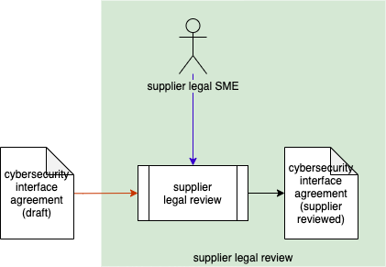

The **cybersecurity interface agreement (draft)** is reviewed by the supplier legal SME. A **cybersecurity interface agreement (supplier reviewed)** is created via annotation.

**Note:** This activity and the **Customer Legal Review** may be performed in parallel.

## Customer Legal Review

|  |  |
| --- | --- |
| **Inputs** | Cybersecurity Interface Agreement (draft) |
| **Outputs** | Cybersecurity Interface Agreement (customer reviewed) |
| **Participants** | Customer Legal SME |

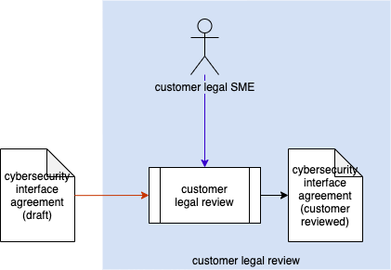

The **cybersecurity interface agreement (draft)** is reviewed by the supplier legal SME. A **cybersecurity interface agreement (customer reviewed)** is created via annotation.

**Note:** This activity and the **Supplier Legal Review** may be performed in parallel.

## Agreement Harmonization

|  |  |
| --- | --- |
| **Inputs** | Cybersecurity Interface Agreement (supplier reviewed)  Cybersecurity Interface Agreement (customer reviewed) |
| **Outputs** | Cybersecurity Interface Agreement (final) |
| **Participants** | Supplier Security SME  Customer Security SME |

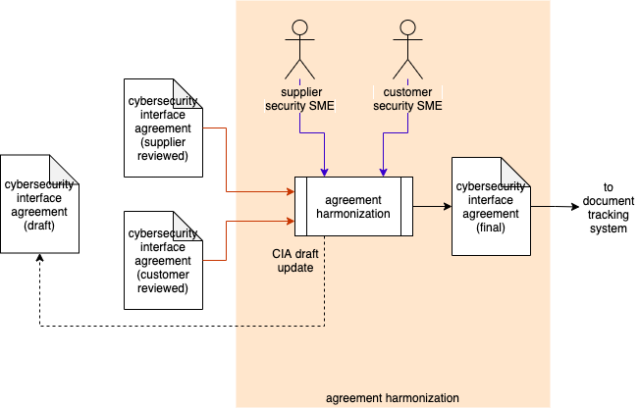

The **cybersecurity interface agreement (supplier reviewed)** and **cybersecurity interface agreement (customer reviewed)** are used by the supplier and customer security SMEs to harmonize any differences. If there are unresolved issues or questions, the harmonized information is fed back into the **cybersecurity interface agreement (draft)** triggering another round of reviews. If there are no unresolved issues or questions, the harmonized information is integrated to **create the cybersecurity interface agreement (final)**. This document is the transferred to the document tracking system for management sign-off and archiving.

# References

1. **UNECE trans WP.29 GRVA 2019 2 - World Forum for Harmonization of Vehicle Regulations: Proposal for a Recommendation on Cyber Security**  
   [**https://unece.org/fileadmin/DAM/trans/doc/2019/wp29grva/ECE-TRANS-WP29-GRVA-2019-02e.pdf**](https://unece.org/fileadmin/DAM/trans/doc/2019/wp29grva/ECE-TRANS-WP29-GRVA-2019-02e.pdf)
2. **Software Package Data Exchange® (SPDX®)**  
   [**https://spdx.dev/wp-content/uploads/sites/41/2017/12/spdxversion2.1.pdf**](https://spdx.dev/wp-content/uploads/sites/41/2017/12/spdxversion2.1.pdf)
3. **ISO 19770-2:2015 Information technology - IT asset management - Part 2: Software identification tag**  
   [**https://www.iso.org/standard/65666.html**](https://www.iso.org/standard/65666.html)
4. **NIST IR 8060 Guidelines for the Creation of Interoperable Software Identification (SWID) Tags**  
   [**https://nvlpubs.nist.gov/nistpubs/ir/2016/NIST.IR.8060.pdf**](https://nvlpubs.nist.gov/nistpubs/ir/2016/NIST.IR.8060.pdf)
5. **NIST SP 800-181 NICE Cybersecurity Workforce Framework (NCWF)**[**https://nvlpubs.nist.gov/nistpubs/SpecialPublications/NIST.SP.800-181r1.pdf**](https://nvlpubs.nist.gov/nistpubs/SpecialPublications/NIST.SP.800-181r1.pdf)
6. **Responsibility Assignment Matrix**[**https://en.wikipedia.org/wiki/Responsibility_assignment_matrix**](https://en.wikipedia.org/wiki/Responsibility_assignment_matrix)
7. **Capability Maturity Model**[**https://en.wikipedia.org/wiki/Capability_Maturity_Model**](https://en.wikipedia.org/wiki/Capability_Maturity_Model)
8. **Software Bill of Materials**[**https://www.ntia.gov/sbom**](https://www.ntia.gov/sbom)
9. **AVCDL** (primary document)
10. **Understanding Cybersecurity Interface Agreements (AVCDL secondary document)**
11. **AVCDL** **Cybersecurity Interface Agreement template.xlsx (AVCDL template document)**
12. **AVCMDS Worksheet template.xlsx (AVCDL template document)**
13. **AVCDL vendor CMM template.xlsx (AVCDL template document)**
14. **Global Security Requirements (AVCDL secondary document)**
15. **Product-level Security Requirements (AVCDL secondary document)**